Name: Robert Acosta Date: 16 September 2020

Instructor: Adrianna Holden-Gouveia

Subject: Linux Administration

# Getting your system set up

**Requirements:**

VMware Workstation

CentOS 8.2 ISO

Ubuntu Server 20.04

Step 1) Open VMware Workstation and select **File => New Virtual Machine**

Step 2) Make sure the option **Typical (recommended)** is selected

Step 3) Select the option **I will install the operating system later.**

Step 4) In Guest Operating System make sure the option **Linux** is selected. In the Version box selection, look for and select **CentOS 8 64-bit**

Step 5) In Virtual machine name: type a name for the virtual machine or leave the default name. In Location: select the path that you would like the virtual machine to be installed on.

Step 6) In Maximum disk size (GB): type or select 20. The recommended amount to install CentOS is 20GB. However, if you would like to expand the virtual machine disk size you can do later. Make sure the **Store virtual as a single file** check box is selected.

Step 7) Open the tab **Customize Hardware…** before clicking Finish. This section depends on your local computer specifications. Click or Select **Memory**. The recommended memory is 1gb, however I personally prefer to go 1 GB higher, so my Virtual Machine could handle more task at once. Select **Processors,** In the **Number processors :** option select 2 and in the **Number of cores per processor** 4.

Step 8) In the same tab **Customize Hardware…** Select **New CD/DVD (IDE)**. Select the option **Use ISO image file:** In your local machine locate and select the file CentOS 8.2 ISO. (It is the file that you just download from centos.org. Close the Tab and press finish.

Step 9) In the left upper conner, press the option **Power on this virtual machine**. Now we are about to get ready to initialize the setup for CentOS.

Note: This process is the exact same process that needs to be done to install Ubuntu Server in the virtual Machine.

## CentOS Setup

Step 1) Using the Keyboard arrows select the option **Test This Media & install CentOS Linux 8.** This option will check for any errors in the media before installing the operating system.

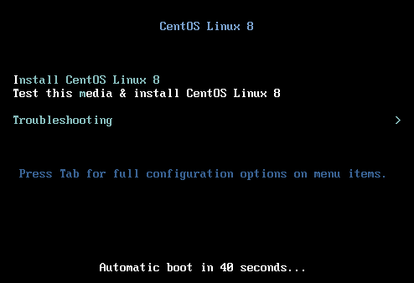

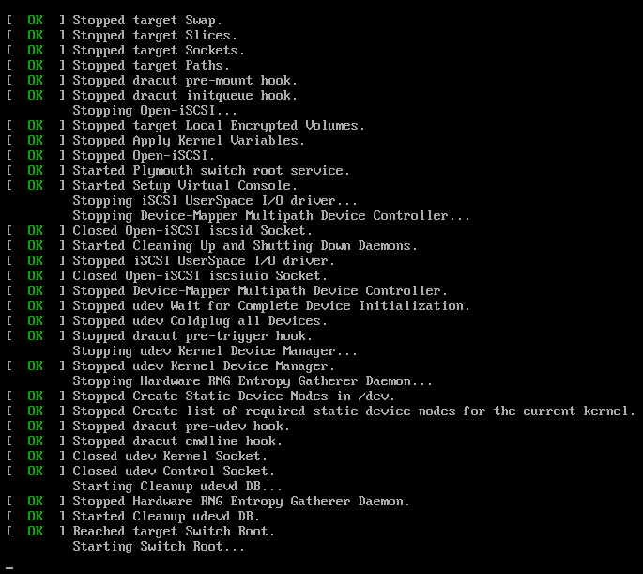

Step 2) Select your preferred language.

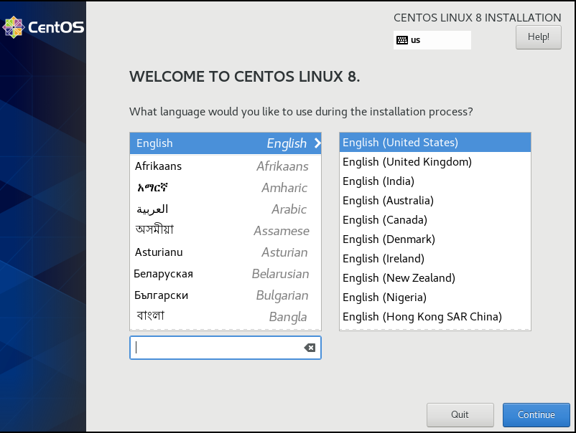

After selecting your preferred language, the Installation Summary will pop up.

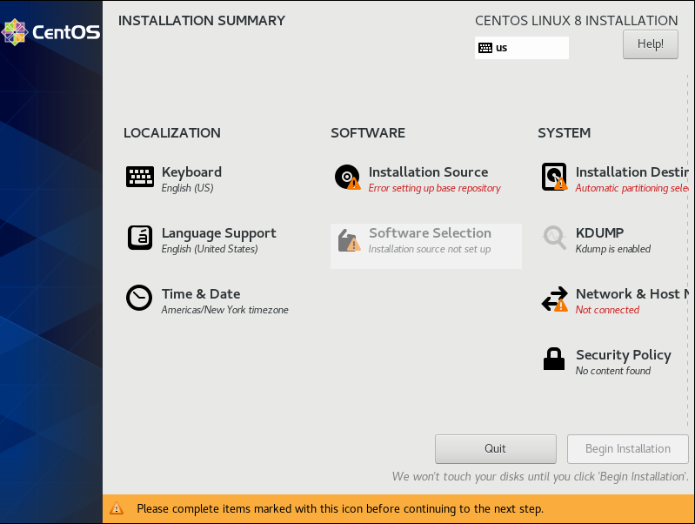

Step 3) In the Installation Summary, select the option **Network & Host**

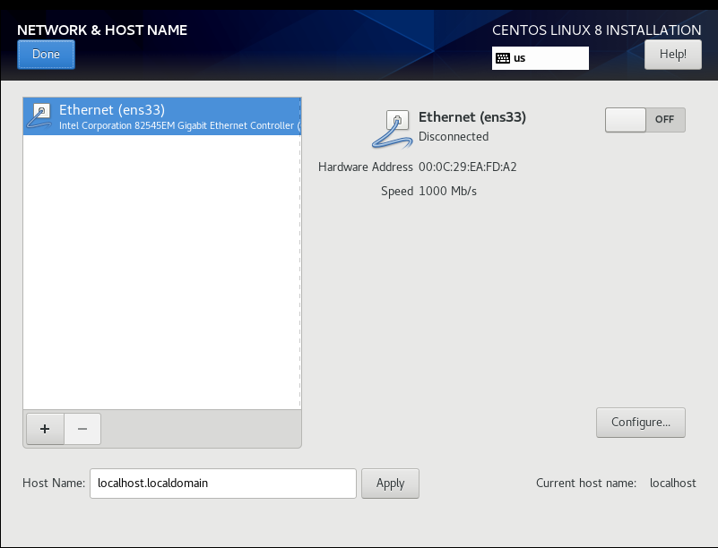

The Ethernet (ens33) will be disconnected. Click inside the box **OFF** to turn it on.

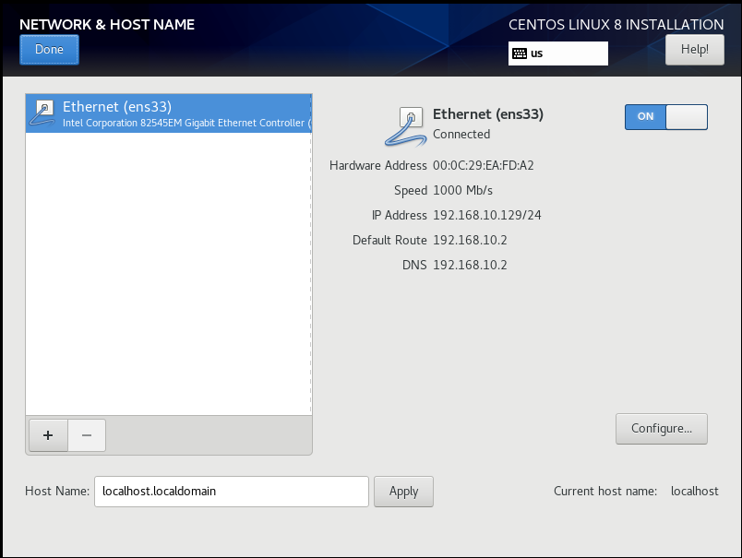

Click **Done** in the Upper Left corner to go back to the Installation Summary

Step 4) In the Installation Summary, select **Installation Destination**

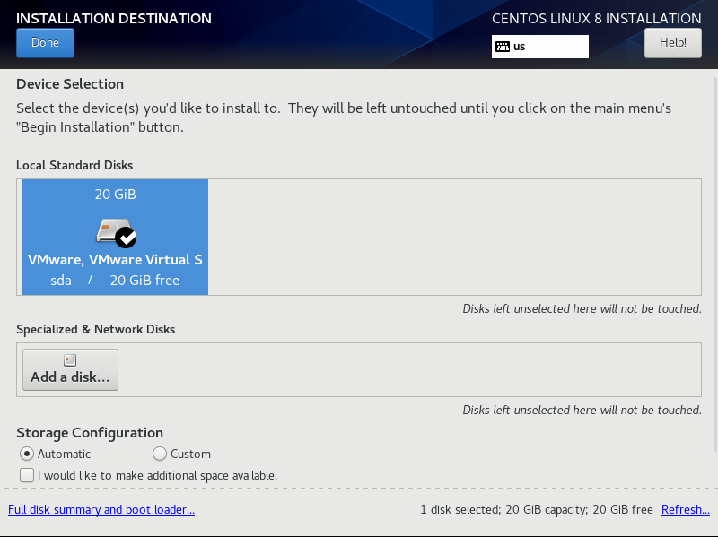

Select the VMware Virtual Disk until you see a check mark. Click **Done** to go back to the Installation Summary.

Step 5) In the Installation Summary, select **Software Selection**

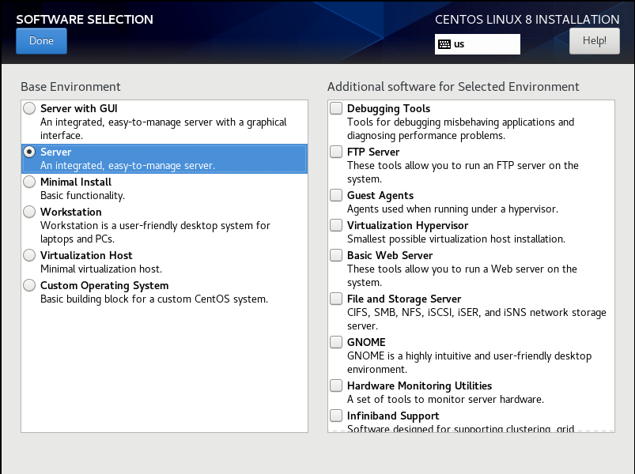  
Make Sure **Server** is check. Click **Done** to go back to the Installation Summary.

Step 6) Select **Begin Installation** in the lower right corner.

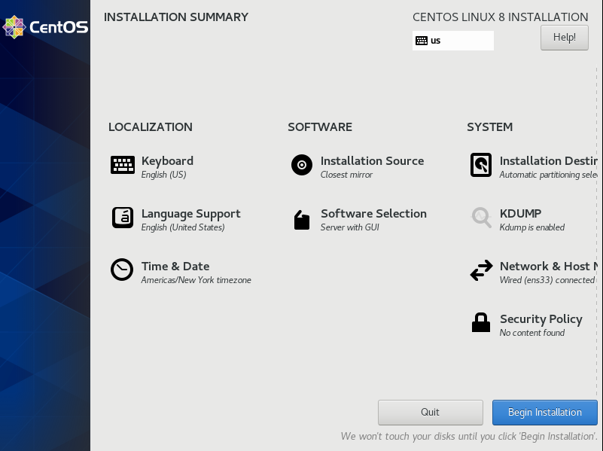

Step 6)During the Installation we can create a Root Password and a User Account

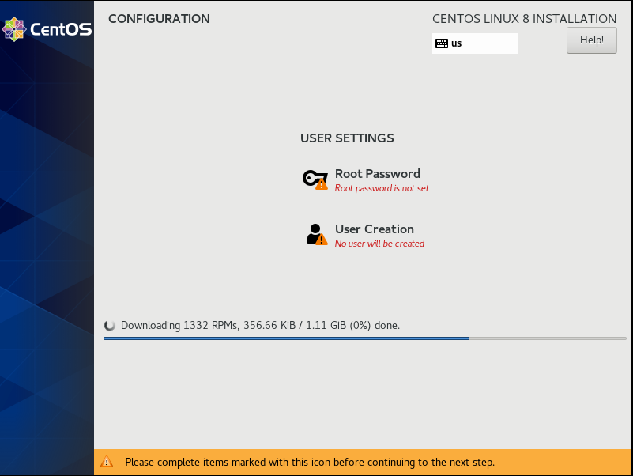

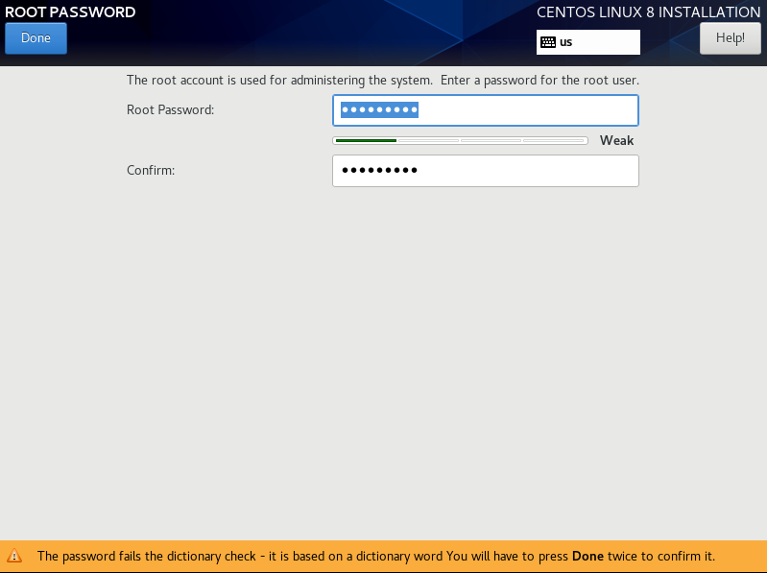

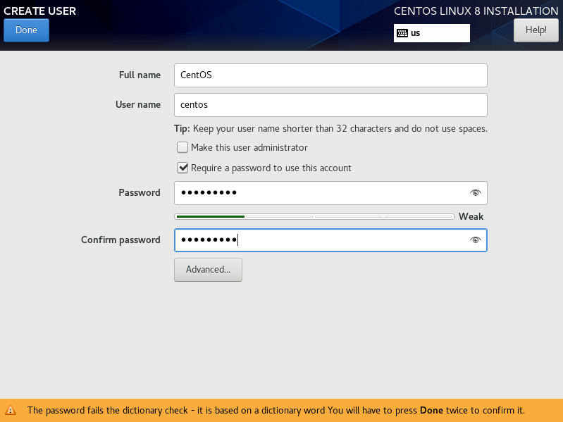

Step 7) After the Installation process is complete, click **Reboot** in the lower right corner.

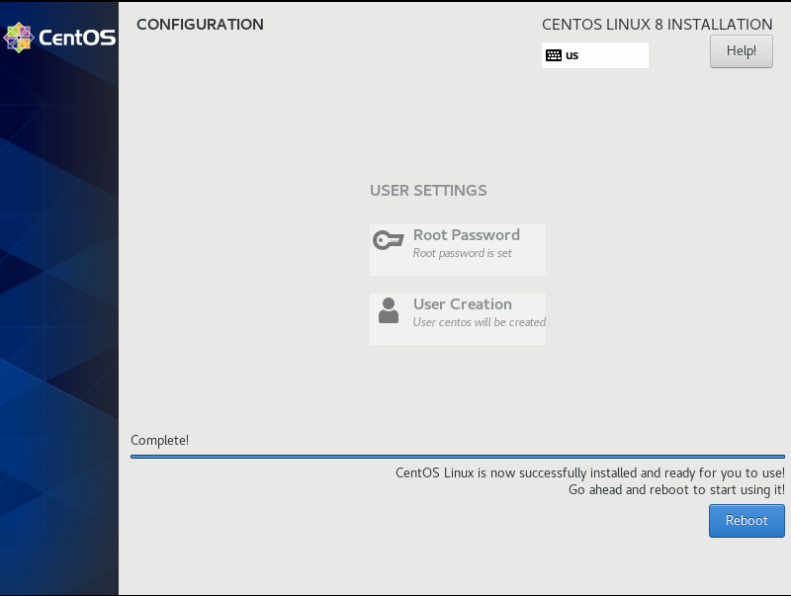

Step 8) The command line will ask the user to enter the login credential. In **CentOS login:** type the username and then the password. Refer to step 6. After entering the credential, the user can begin to use the command line.

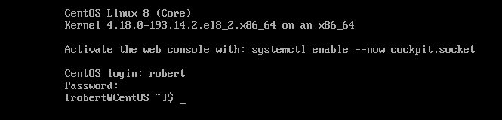

## Installing Ubuntu Server

Step 1) Using the Up and Down keys select the preferred language of your choice.

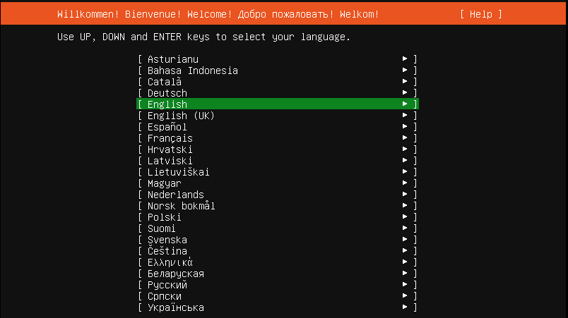

Step 2) Select the keyboard layout

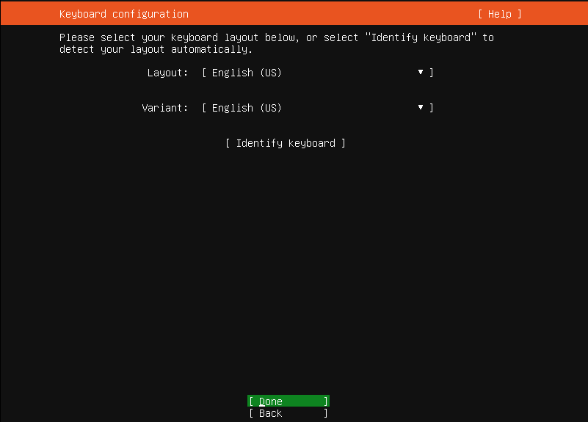

Step 3) Make sure that at least one internet adapter shows up. As we can see the **ens33** is the virtual machine network adapter and it is selected in the screen with the IP of 192.168.10.131/24

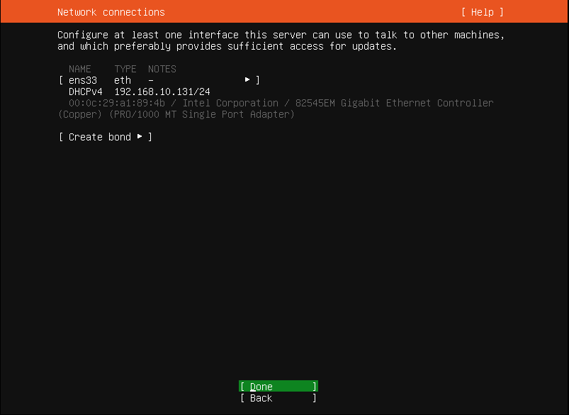

Step 4) A proxy server is a server that acts as intermediary for request. In this case we leave it blank.

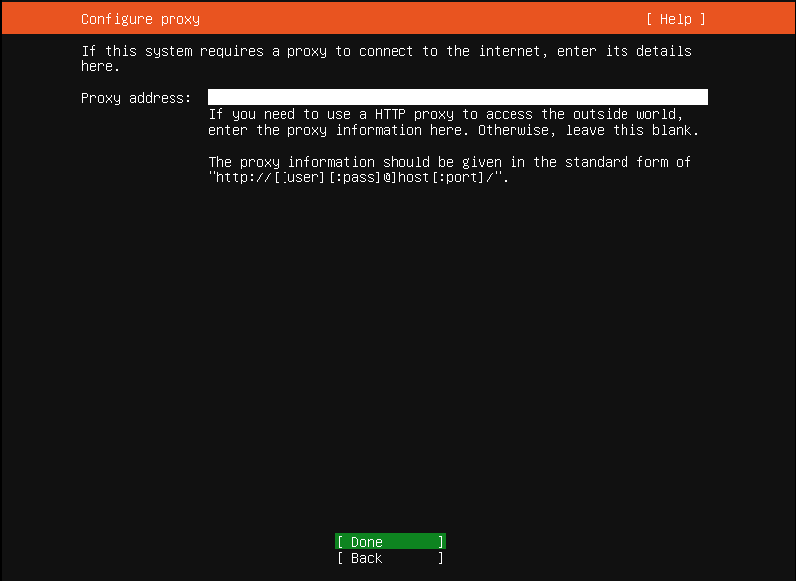

Step 5) The mirror address is where you want the file to be downloaded. Leave the default address and press enter to continue.

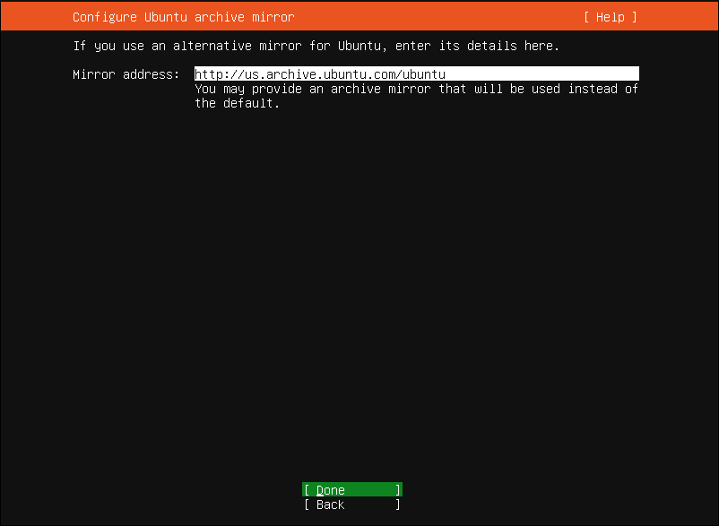

Step 6) Make sure to check **Use entire Disk**. This will allow the user to use the entire disk that was specified in the virtual machine.

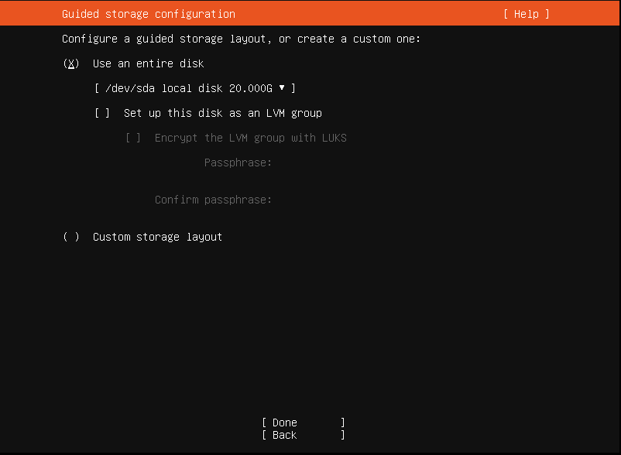

Step 7) A summary of the partition that will be installed in the disk drive. After pressing Enter a message will appear asking the user that the selected partition will be formatted. Go ahead and press **continue.**

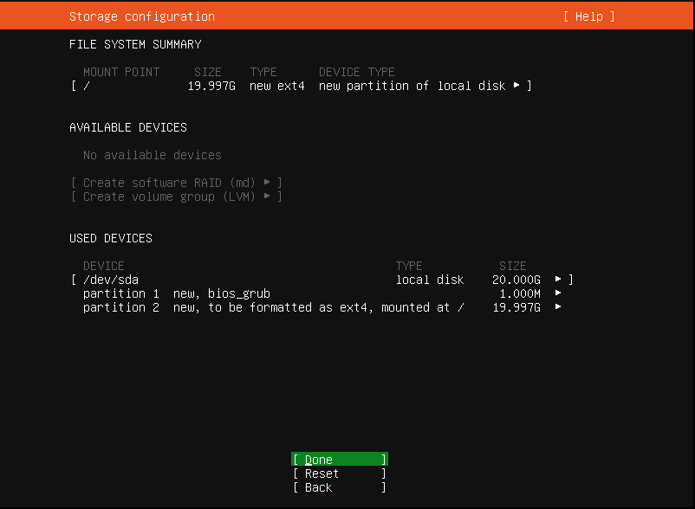

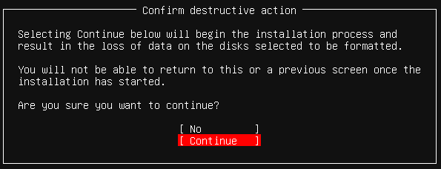

Step 8) Enter the credentials such as Your Name, Server Name and Password.

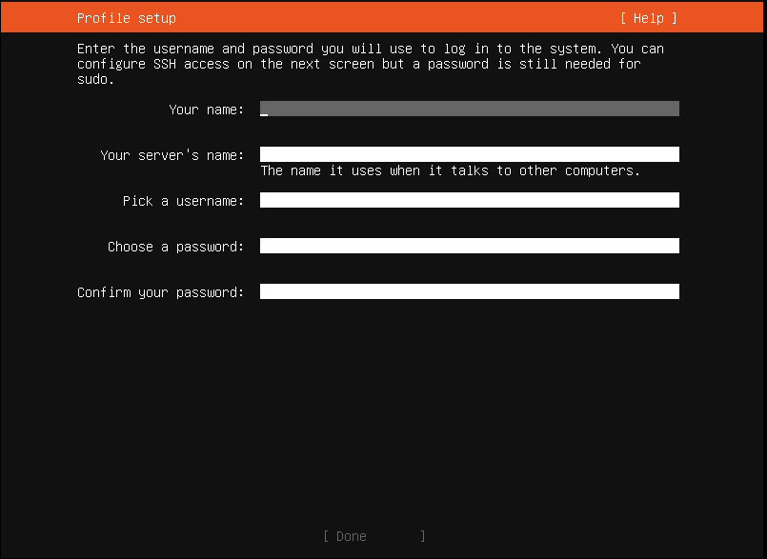

Step 9) Make sure **Install OpenSSH Server** is check

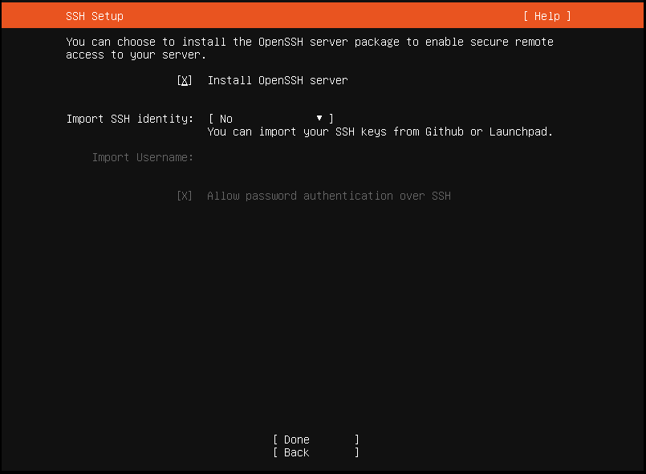

Step 9) These are additional features and package that are available before the installation process. Read carefully and choose wise. Press enter when done.

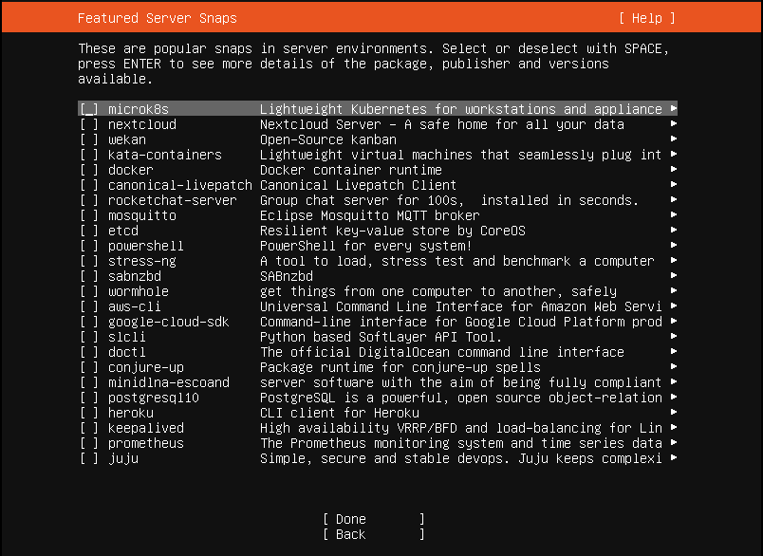

Step 10) Once the installation is over, select **Reboot**

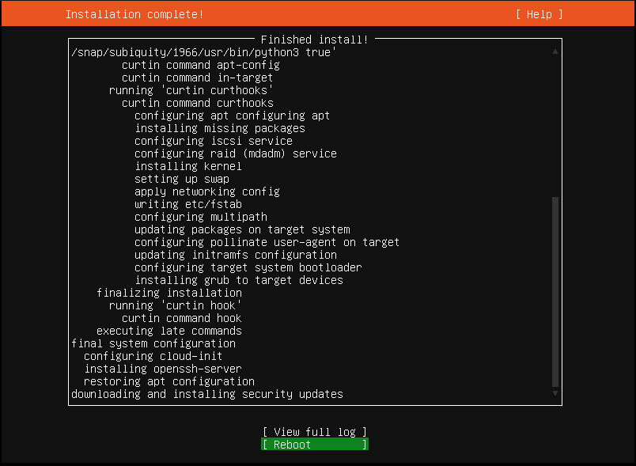

Step 10) Once the reboot is done the command line will appear asking for the login credential. On ubuntu server login: type your username and then the password.(refer to step 8)



After the entering the credential, the user will be able to use the server.

